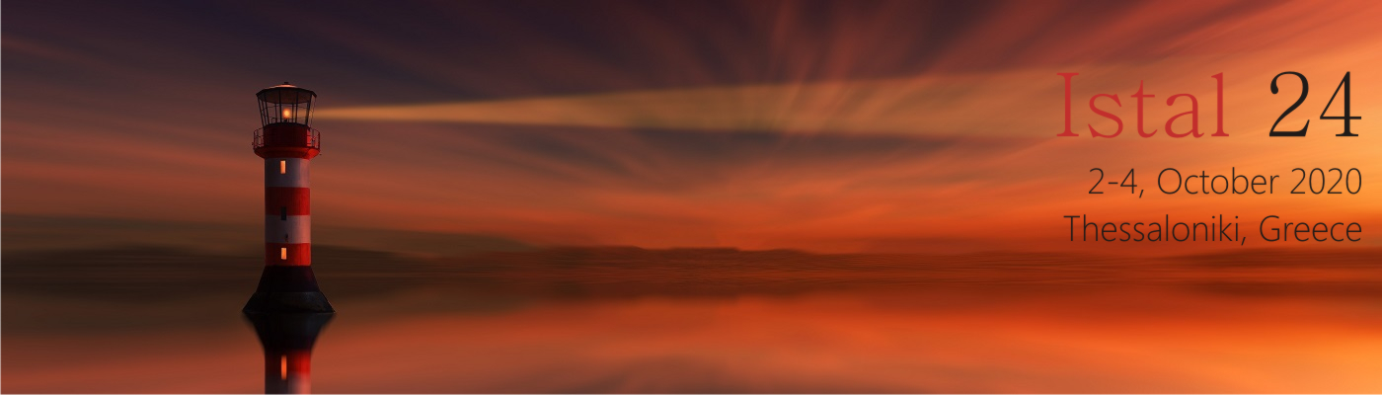

**24th ISTAL**

The Department of Theoretical and Applied Linguistics of the School of English, Aristotle University of Thessaloniki is pleased to announce the **virtual** 24th International Symposium on Theoretical and Applied Linguistics to be held on **2-4 October 2020**. We are delighted to welcome as invited speakers the following scholars:

* Ghada Khattab
* Enric Llurda
* David Marsh
* Kiki Nikiforidou
* Ianthi Maria Tsimpli

For registration and more information visit <http://www.new.enl.auth.gr/istal24/>

For enquiries, please contact [istal24@enl.auth.gr](mailto:istal24@enl.auth.gr)

Organizing Committee

Areti-Maria Sougari

Angeliki Athanasiadou

Katerina Nikolaidis

Valandis Bardzokas

Maria Dimitrakopoulou

Maria Moumtzi